TASK 3: SHELL SCRIPT AUTOMATION
Internship Name: Linux Fundamentals Internship
Task Title: System Health Checker Script

1. INTRODUCTION
Shell scripting is an important part of Linux system administration and automation. It allows users to automate repetitive tasks, monitor system performance, and manage system resources efficiently.
In this task, a simple shell script is created to check the basic health of the Linux system. The script collects system information such as date and time, uptime, memory usage, and disk usage.
2. OBJECTIVE
The objective of this task is to:
Understand basic shell scripting concepts
Automate system monitoring tasks
Learn how to execute shell scripts in Linux
Gain practical experience with Bash scripting
3. TOOLS & ENVIRONMENT USED
Operating System: Kali Linux
Terminal: Linux Terminal
Text Editor: Nano
Shell: Bash
4. TASK DESCRIPTION
A shell script named system_health.sh is created to automatically display:
Current date and time
System uptime
Memory usage
Disk usage
This script helps administrators quickly check system status without manually running multiple commands.
5. STEP-BY-STEP IMPLEMENTATION
Step 1: Open Terminal
The Linux terminal was opened using the application menu in Kali Linux.
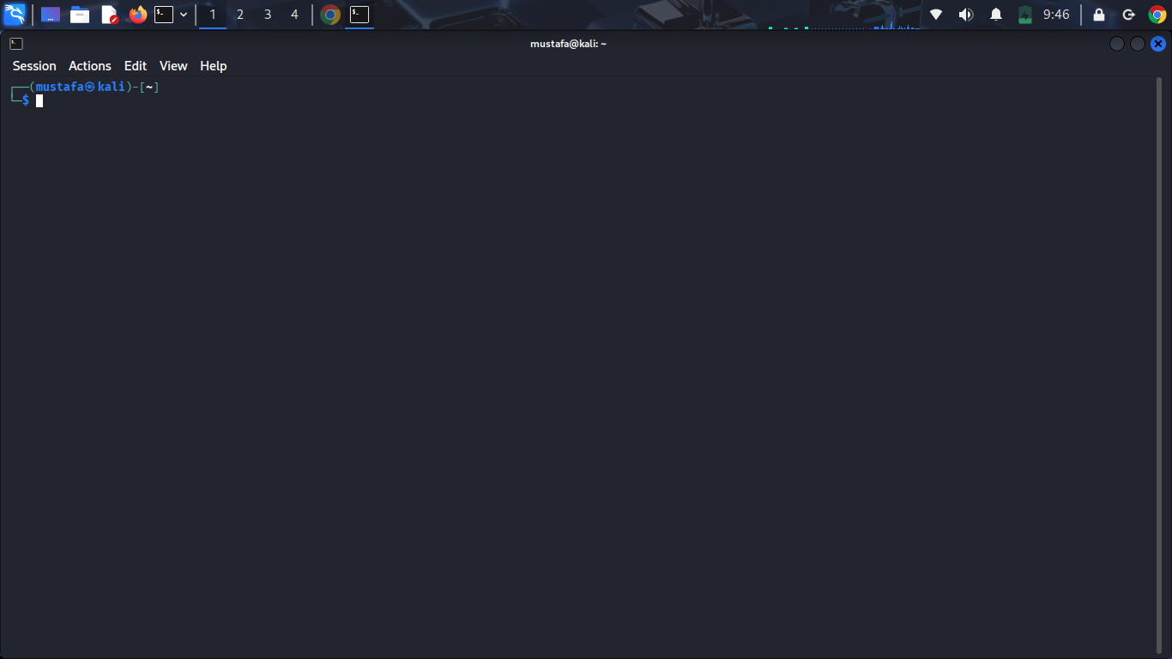
Step 2: Create Shell Script File
The following command was used to create and open a shell script file:
nano system_health.sh
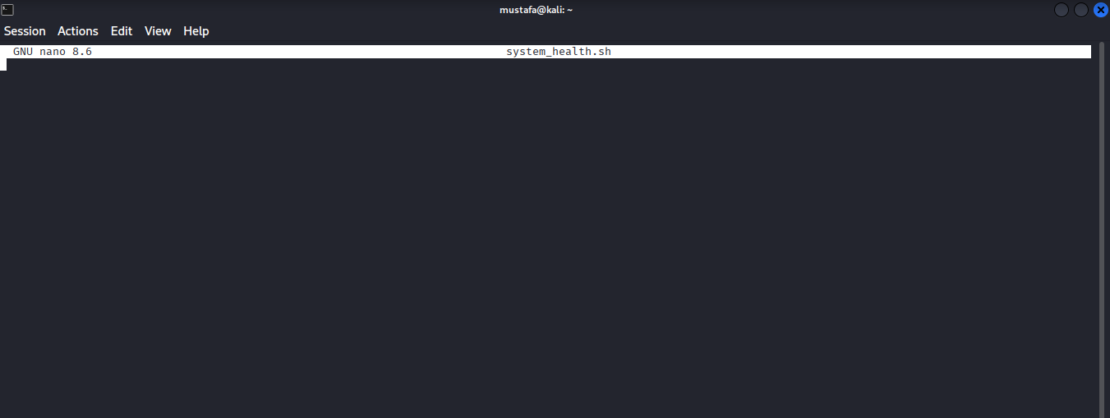
Step 3: Write the Shell Script Code
The following Bash script was written inside the file:
#!/bin/bash
echo "=================================="
echo " SYSTEM HEALTH REPORT "
echo "=================================="
echo "Date and Time:"
date
echo "----------------------------------"
echo "System Uptime:"
uptime
echo "----------------------------------"
echo "Memory Usage:"
free -m

echo "----------------------------------"
echo "Disk Usage:"
df -h
echo "=================================="
echo " REPORT COMPLETED "
echo "=================================="
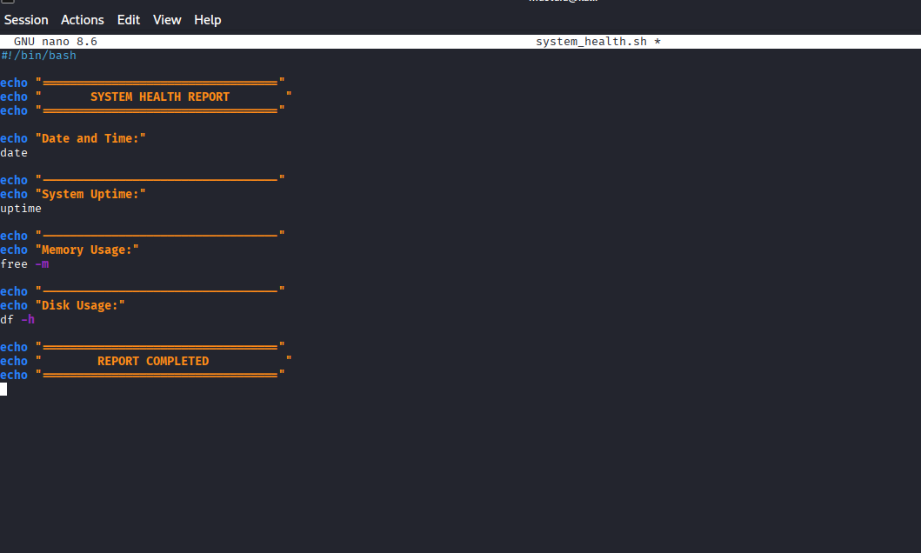
Step 4: Save the Script File
The script file was saved using the following keys:
CTRL + O → Press Enter
CTRL + X → Exit editor
Step 5: Provide Execute Permission
Before executing the script, execute permission was granted using the chmod command:
chmod +x system_health.sh
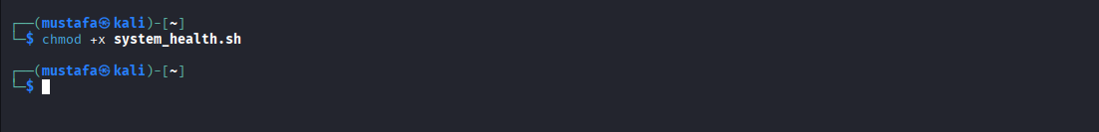
Step 6: Execute the Script
The script was executed using the following command:
./system_health.sh
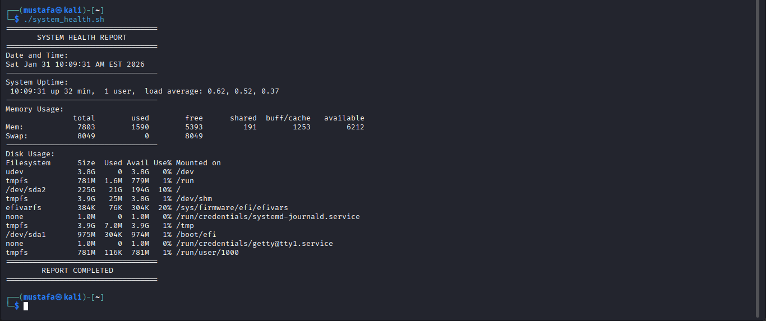
6. SCRIPT OUTPUT DESCRIPTION
After execution, the script displayed:
System date and time
Total system uptime
Memory usage in megabytes
Disk usage in human-readable format
This output confirms that the script is functioning correctly and collecting system health information.
7. LEARNING OUTCOMES
Through this task, the following skills were learned:
Creating and editing shell scripts
Using Bash commands in automation
Understanding file execution permissions
Monitoring Linux system resources
Basic scripting logic and structure

8. REAL-WORLD APPLICATION
System administrators and DevOps engineers use similar scripts to:
Monitor server health
Automate routine system checks
Reduce manual work
Improve system reliability
This task provides real-world exposure to Linux automation techniques.
9. CONCLUSION
This task successfully demonstrated the creation and execution of a shell script for system health monitoring. Shell scripting is a powerful tool in Linux environments and is essential for careers in Cyber Security, DevOps, Cloud Computing, and System Administration.

